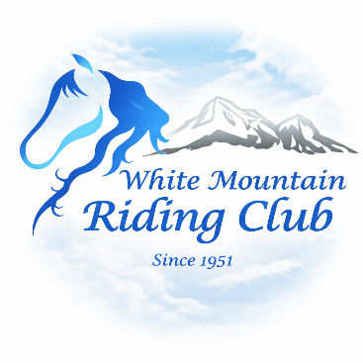
WHITE MOUNTAIN RIDING CLUB
Trail Ride Registration, Liability Waiver
Office Use Only:
- Paid Members only
- Signed Release
& Participant Agreement

Trail Ride
South Wheelock, VT
May 24, 2026

Sign Up required by May 10, 2026

PARTICIPANT INFORMATION
Full Name:
Date of Birth (if under 18):
Address:
City/State/Zip:
Phone: _________________________________________ Email: _______________________________________
Emergency Contact Name:
Emergency Contact Phone:

HORSE INFORMATION (if applicable)
Horse Name:
Owner (if different):

HEALTH & REQUIREMENTS VERIFICATION (Initials required)
___ Proof of Coggins (equine traveling over state lines required) and Rabies is required – Must supply copy

HELMET REQUIREMENT (Initials required)
___ I understand that all riders under 18 are required to wear an ASTM/SEI-approved helmet while
mounted
___ I understand helmet use is strongly recommended for all riders

EQUINE ACTIVITY LIABILITY RELEASE & WAIVER
I understand that participation in equine activities involves inherent risks, including but not limited to:
- The unpredictable nature and behavior of horses
- Horses reacting to sounds, movement, wildlife, or environmental factors
- Uneven footing, terrain changes, mud, rocks, and natural obstacles
- Weather conditions and visibility changes
- Falls, collisions, or loss of control

Ride at Your Own Risk / Assumption of Risk / Release of Liability
I understand and agree that this is a ride at your own risk activity. I voluntarily choose to participate and assume all risks, known and unknown. I hereby release and hold harmless the White Mountain Riding Club, its officers, members, volunteers, ride leaders, landowners, and affiliates from any and all liability for injury, death, or property damage arising from participation, to the fullest extent permitted by law.

NEW HAMPSHIRE & VERMONT LAW NOTICE
New Hampshire (RSA 21:34-a):
“Each participant in an equine activity expressly assumes the risk of injury or loss resulting from the inherent risks of equine activities.”
Vermont (12 V.S.A. § 1039):
“An equine activity sponsor shall not be liable for injury or death resulting from the inherent risks of equine activities.”

GROUP RIDE RULES & SAFETY AGREEMENT
By signing below, I agree to:
- Follow all instructions from ride leaders and staff
- Maintain safe spacing (minimum one horse length)
- Do not pass other riders unless directed
- Ride at the designated gait and speed
- Keep my horse under control at all times
- Notify staff of any horse with kicking, biting, or unsafe behavior
- Stay on designated trails
- Avoid reckless behavior, racing, or unsafe conduct
- Refrain from alcohol or drug use during the event
- There are no dogs or other pets allowed on the trail ride. Please leave them home.
- No ponying or leading horses. Ridden horses only.

___ I understand that failure to follow these rules may result in removal from the ride and prohibited from future WMRC events.

HORSE & EQUIPMENT RESPONSIBILITY
___ I certify that my horse is safe, sound, and suitable for trail riding
___ I certify that my tack and equipment are safe and properly fitted

EMERGENCY MEDICAL AUTHORIZATION
___ I authorize the White Mountain Riding Club to obtain emergency medical care for me (or my child) if necessary and accept responsibility for any associated costs.

MEDIA RELEASE
___ I grant the White Mountain Riding Club (WMRC) permission to use photographs, video, or other media of me (or my minor child) for promotional, advertising, and educational purposes in any format, including social media and websites, without compensation.

I have read, understand, and agree to all terms in this document.

Participant Signature:

Date:

MINOR PARTICIPANT (if applicable)
I certify that I am the parent/legal guardian of the minor listed above and consent to their participation.

Parent/Guardian (if minor):

Date:

