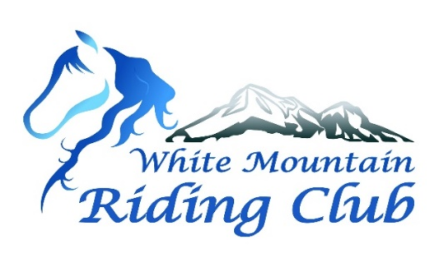
Mailing address:
Tammi Woida, Treasurer
White Mountain Riding Club
298 Main St.
Lancaster, NH 03584

Membership Application
□ Individual Membership - $5
□ Family Membership - $10 (Includes parents/legal guardians and children under 18)

New Member: □ OR Renewal: □ Application for the year 20___

Name: __________________________________________________________ DOB if minor: _________
Family Members:
Legal spouse and each child under the age of 18 by Jan. 1 of membership year.

- Name: _______________________________________________________DOB: ___________
- Name: _______________________________________________________DOB: ___________
- Name: _______________________________________________________DOB: ___________
- Name: _______________________________________________________DOB: ___________
- Name: _______________________________________________________DOB: ___________

Mailing address: ________________________________________________________________________
________________________________________________________________________
~ Valid mailing address must be provided in order to receive election ballots, etc.. ~

Email address: __________________________________________________________________________
Phone: ________________________________________________________________________________
I hereby agree to abide by the By-Laws of the White Mountain Riding Club.
Signature: _______________________________________________________ Date: _________

Membership runs from Jan. 1 through Dec. 31. Please make checks payable to White Mountain Riding Club.
Contact us at whitemountainridingclub@gmail.com.

For Office Use Only:
Date: ______________
Check #: ______ or Cash: ____
Rec’d. By: __________

